**CPE166 Advanced Logic Design**

**Lab 3 Report:**

**VHDL Structural Design and Usage of Logic Analyzer**

**Student Name: Andy Cha**

**Date: 5-01-2020**

**California State University, Sacramento**

**TABLE OF CONTENTS**

**Section Page**

Title Page …………………………………………………………………................................ 1

Table Of Contents .………………………………………………………………….................... 2-3

Introduction ………………………………………………………………….............................. 4

Part 1: MHz BCD Counter Design and Logic Analyzer ……………………………………... 5

Design Purpose …………….……………………………………………………………………... 5

Design Experiments ………………………………………………………………………………. 5

Design Source Code ………………………………………………………………………….. 5-6

Simulation Waveform of clk2 and BCD Counter Waveforms …………………………………. 7

Result Discussion ……………………………………………………………………………… 8

Part 2: Pseudorandom Number Generator and Hamming Code Displays on LEDs …….. 8

Design Purpose …………….……………………………………………………………………... 8

Design Experiments ………………………………………………………………………………. 9

Design Source Code ………………………………………………………………………….. 9-13

Simulation Waveform ……………………………………....…………………………………. 13-14

Result Discussion ……………………………………………………………………………… 14

## Part 3: Calculator Design with Multiplexed Seven Segment Displays ……………………. 14

Design Purpose …………….……………………………………………………………………... 14

Design Experiments ………………………………………………………………………………. 14-15

Design Source Code ………………………………………………………………………….. 15-20

Simulation Waveform ……………………………………....…………………………………. 20

Result Discussion ……………………………………………………………………………… 21

## Part 4: RAM Design and Logic Analyzer ……………………………………………………… 21

Design Purpose …………….……………………………………………………………………... 21

Design Experiments ………………………………………………………………………………. 21

Design Source Code ………………………………………………………………………….. 22-25

Simulation Waveform ……………………………………....…………………………………. 25

Result Discussion ……………………………………………………………………………… 25

Conclusion ………….……………………………………………………………………………. 26

**Introduction**

The objective of this lab is to learn structural design using VHDL and learn finite state machine design. Then we will write testbenches in VHDL and learn to simulate our program. Since campus is closed and lab sessions are online, we will not be using the FPGA with Xilinx to monitor our design signals. There will be 4 parts to this lab. The first part of this lab is to design a 1MHz BCD Up-Down Counter. Here we will familiarize ourselves with VHDL and learn the importance of a clock divider. The second part, we will be designing a pseudo random generator using a Linear Feedback Shift Register with Hamming Code. The third part of this lab is to design a LED calculator using the previous modules such as the LFSR and make it perform a calculator function according to the values of button b3 and b4. The final part of this lab is to create a Ram Design that would write binary data "1010" into 16 address locations of the RAM.

**Part 1: MHz BCD Counter Design and Logic Analyzer**

**Design Purpose:**

The objective of this part is to design a 1MHz BCD counter that would count from 0 to 9. If the switch is high impedance, then it will begin counting up from 0. If the counter is at 9 and counts up, it will loop to 0. It will also loop back from 0 to 9 if low. We also need to utilize clock division within our design in order to lower the native 100MHz frequency from the FPGA down to 1MHz so that we could visually see the changes happening. If we don’t then they will be changing too fast for us to see. So it would take the clock to go 100000000 clock cycles before the clock division becomes ‘1’.

**Design Experiments:**

We only need 2 files: bcdcounter(clk div & bcdcounter) and the testbench bcdcounter_tb.

**Design Source Code:**

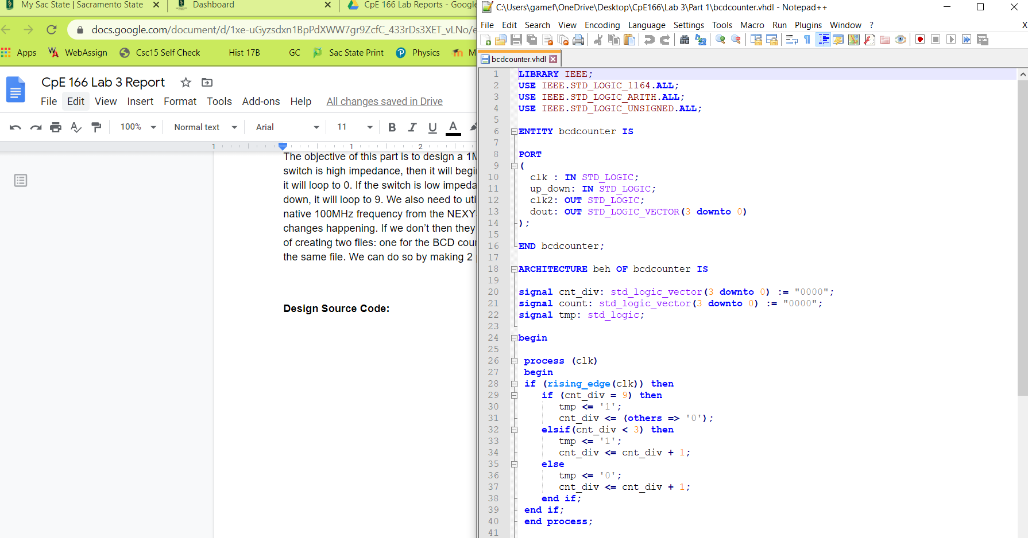

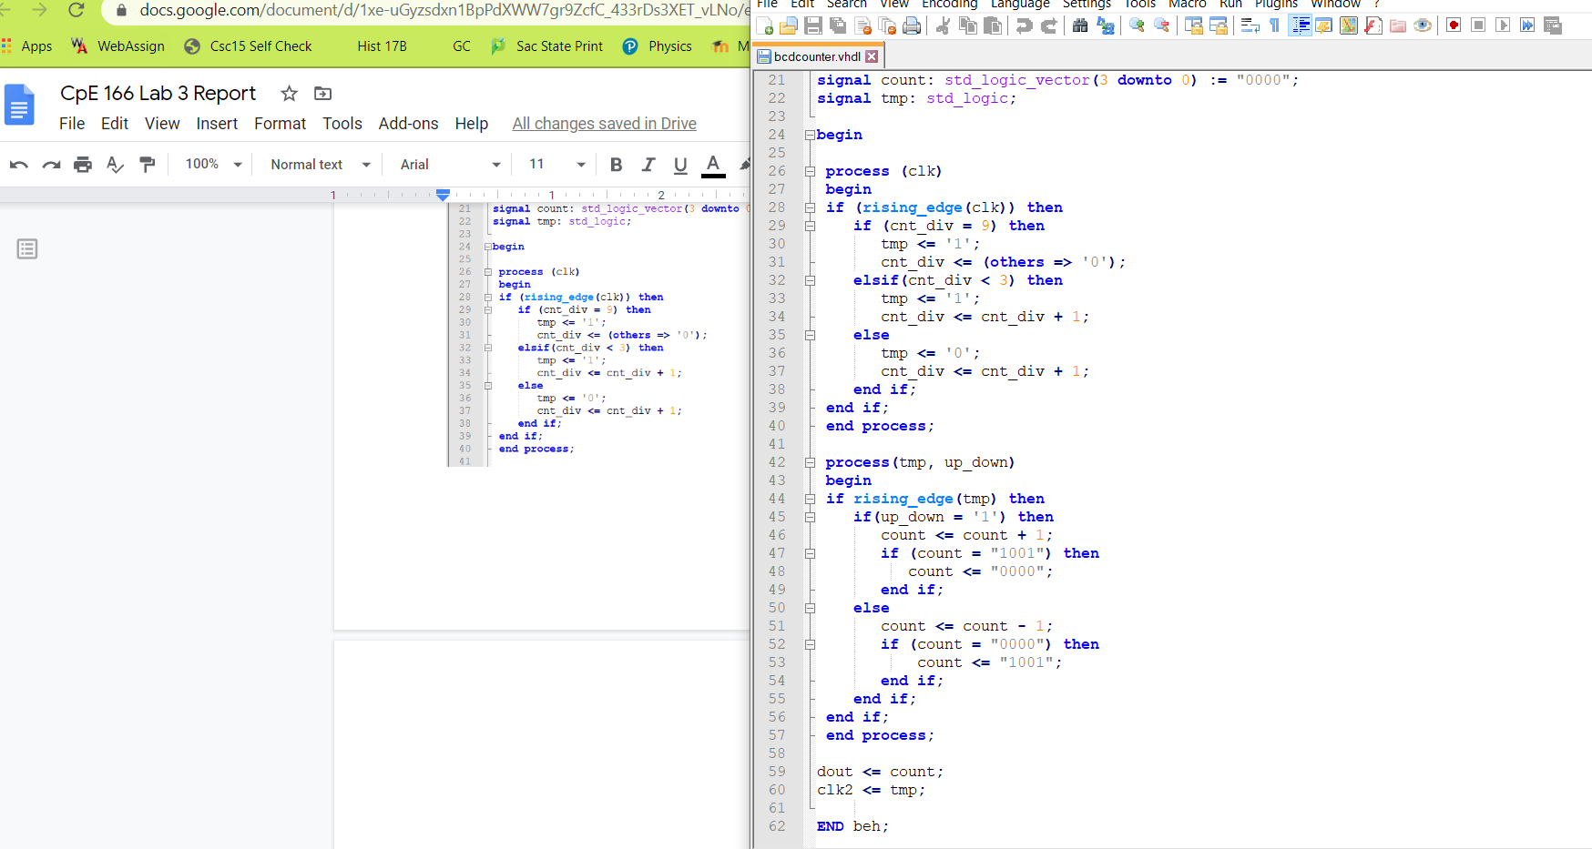

Testbench:

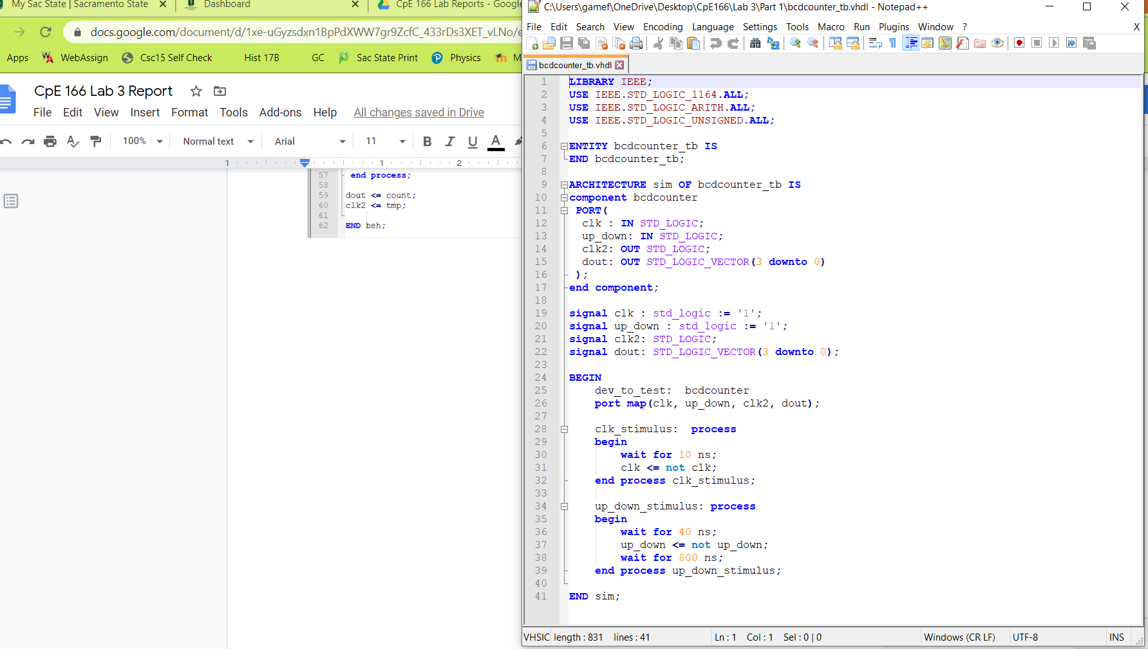

**Simulation Waveform of clk2 and BCD Counter Waveforms:**

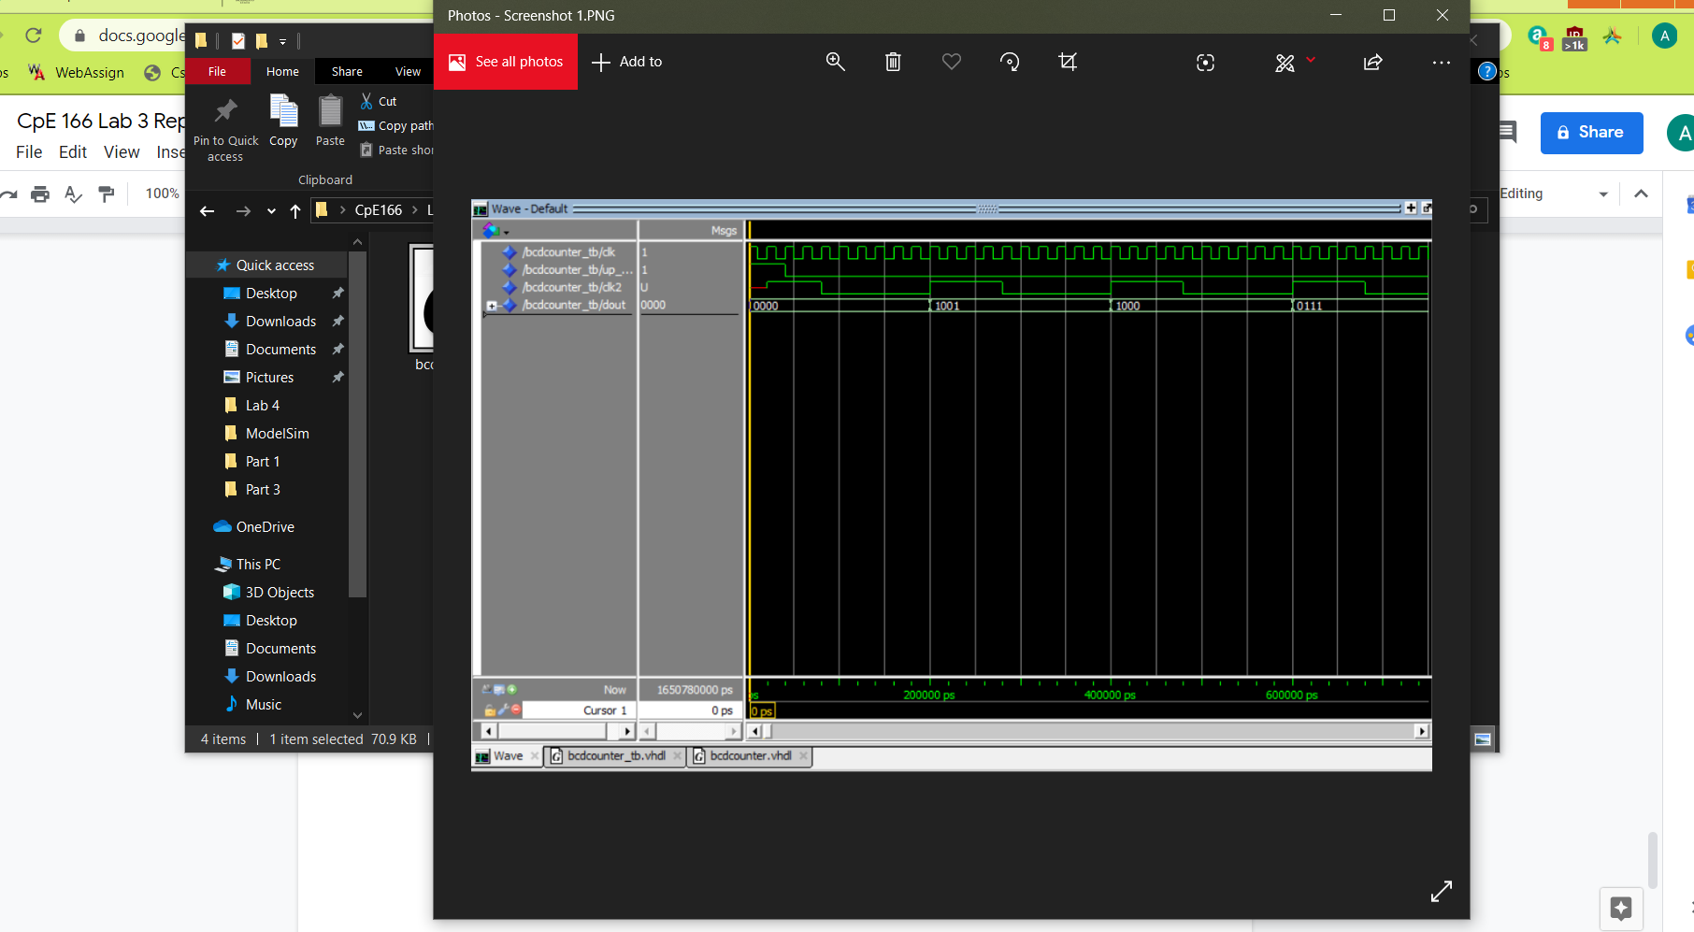

The waveform above we can see that clk2 is a slower version of clk so we know that the clock division is working. Next we see that ‘dout’ starts as ‘0000’ but because the up_down flip is ‘0’ for the next 3 clock cycles, it loops back to 9 (1001), 8(1000), and then 7(0111).

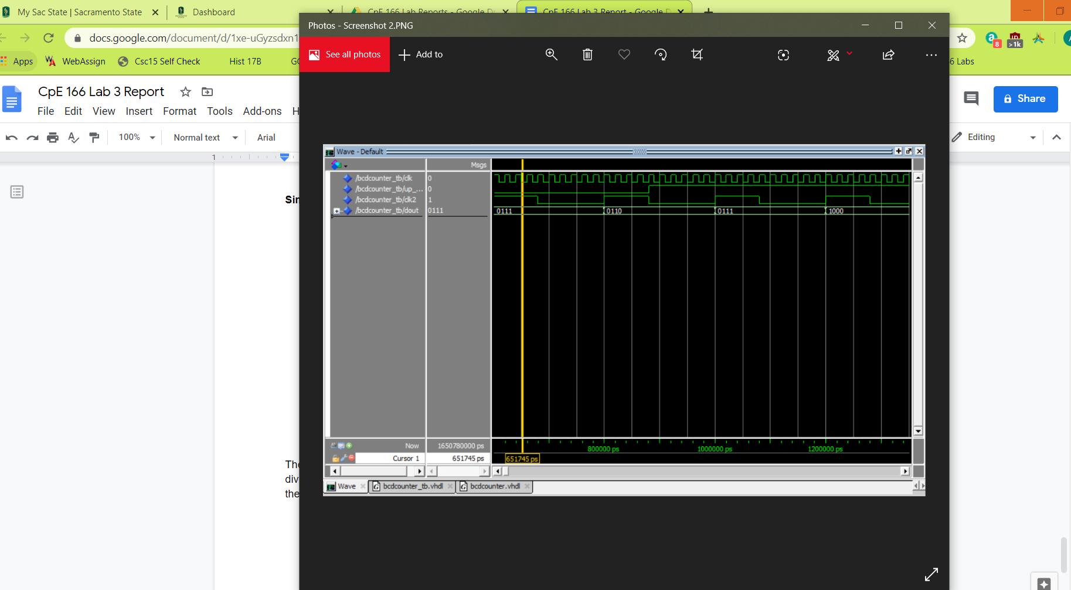

In this picture we see the ‘up_down’ switch becomes ‘1’ therefore ‘dout’ starts to increment up for each rising clock edge of clk2.

**Result Discussion:**

When the user would push the ‘up_down’ switch to high, the output ‘dout’ would count up from 0-9. When the switch is low, the counter counts down from 9-0. We can also see that clk2 is a slower version of clk so we know that the clock division works. This part wasn’t too bad because the bcd-counter and clock division code was given to us on the course webpage. We just had to modify the code a little bit to make it work.

**Part 2: Pseudorandom Number Generator & Hamming Code Displays on LEDs**

**Design Purpose:**

The objective of part was to design a pseudo random number generator that used a LFSR (linear feedback shift register) of the order X^4 + X + 1. The four D-Flip Flops used in LFSR circuit output 4-bit values. When switch 1 (SW1) is pressed, the finite state machine (FSM) will be in the idle state displaying “0000”. When switch 2 (SW2) is pressed, the LFSR value will be displayed as a 4-bit message. When switch 3 (SW3) is pressed, the (7, 4) hamming code will be constructed and displayed on the LEDs. If the original LFSR 4 bit message is ‘1011’ then the Hamming code would be ‘1010101’ because the Hamming code would be arranged as d4 d3 d2 p3 d1 p2 p1. ‘d’ would be the data and the ‘p’ would be the parity bits.

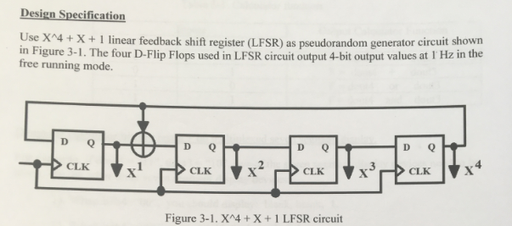

**Design Experiments:**

For this part of the lab, we only need 6 files:

clockDiv - this file will change the original clk cycle to a 1Hz clock cycle

lfsr - this file will do the arithmetic math of the 4 D-flip-flops for the LFSR

hamming - this file will take the 4-bit LFSR and give the Hamming code by determining the data bits(d) and parity bits(p) and output the (7,4) Hamming code arrangement.

fsm - This will determine what dout will be by looking at inputs. The FSM will have 3 states.

Top - Connects clockDiv, lfsr, Hamming, and fsm file to create the circuit design as shown.

Top_tb - testbench for the top file.

**Design Source Code:**

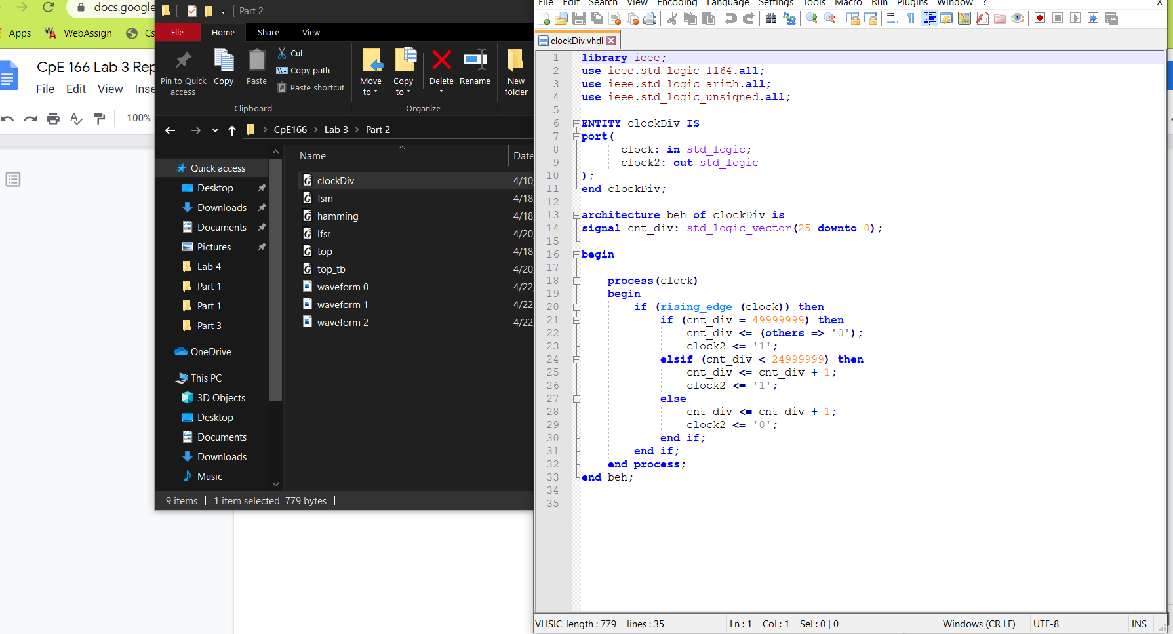

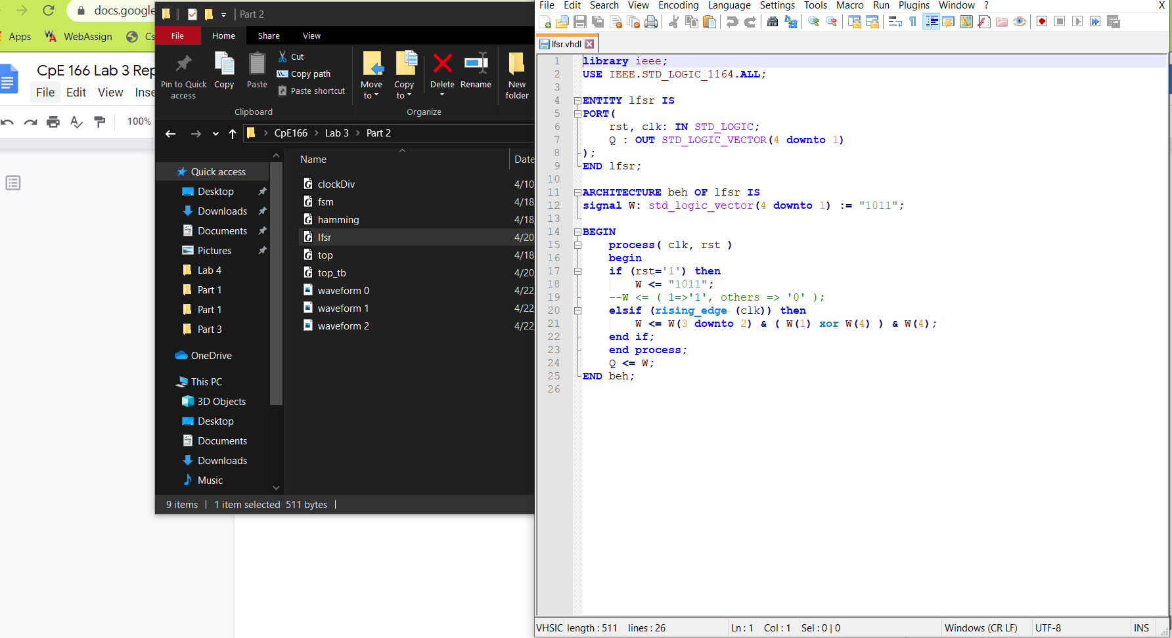

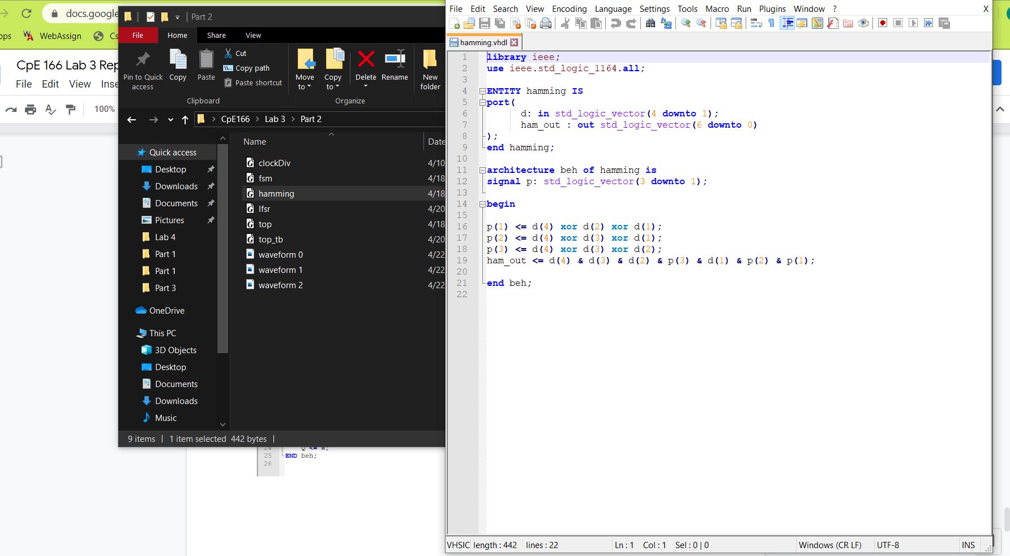

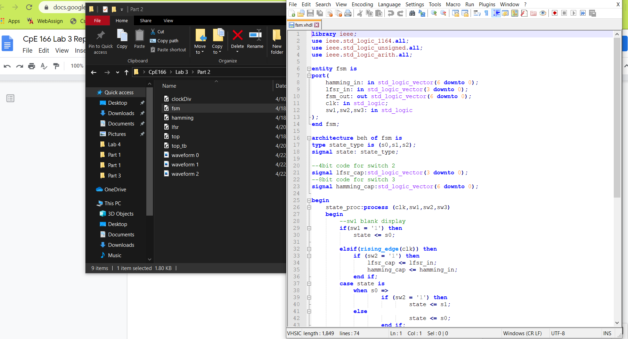

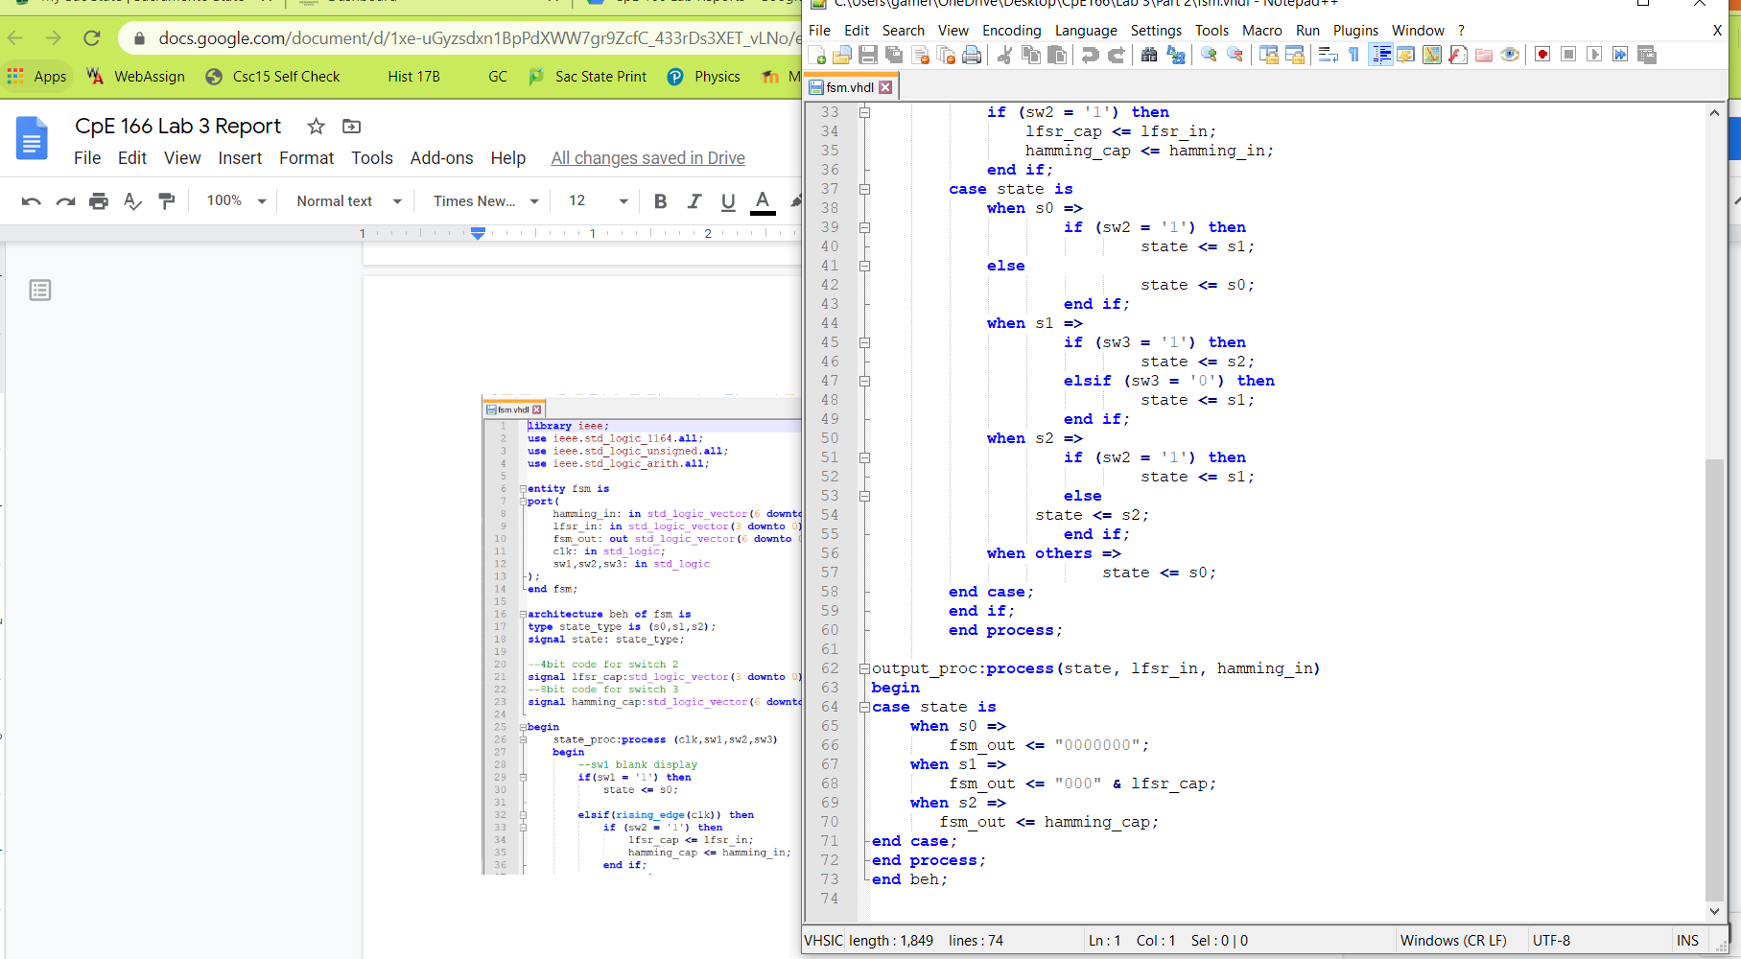

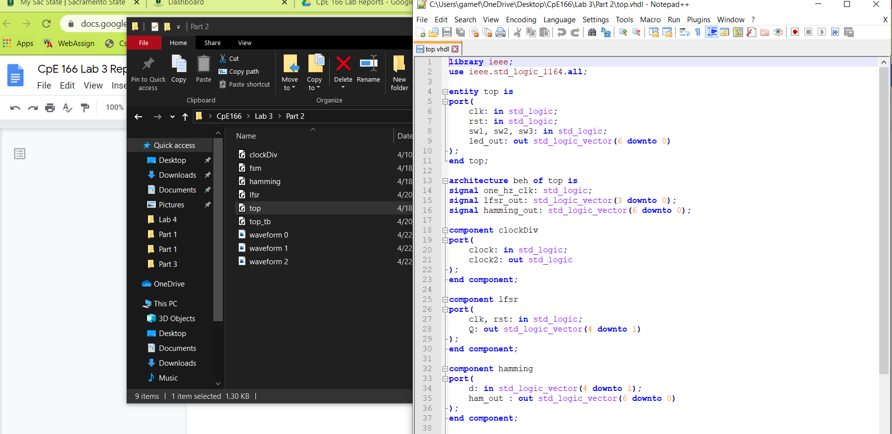

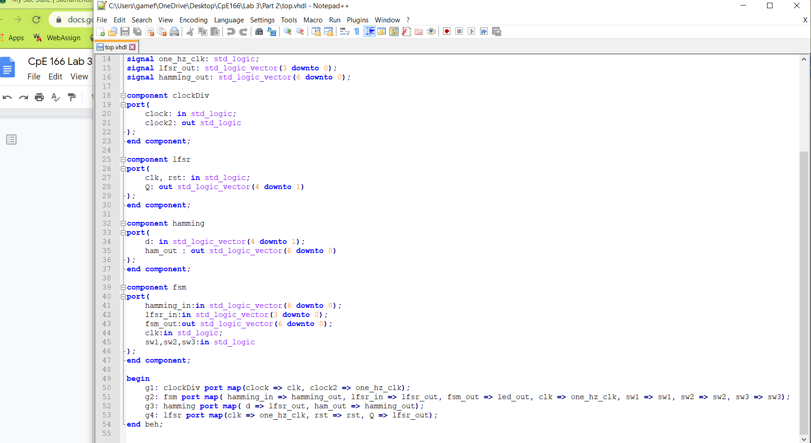

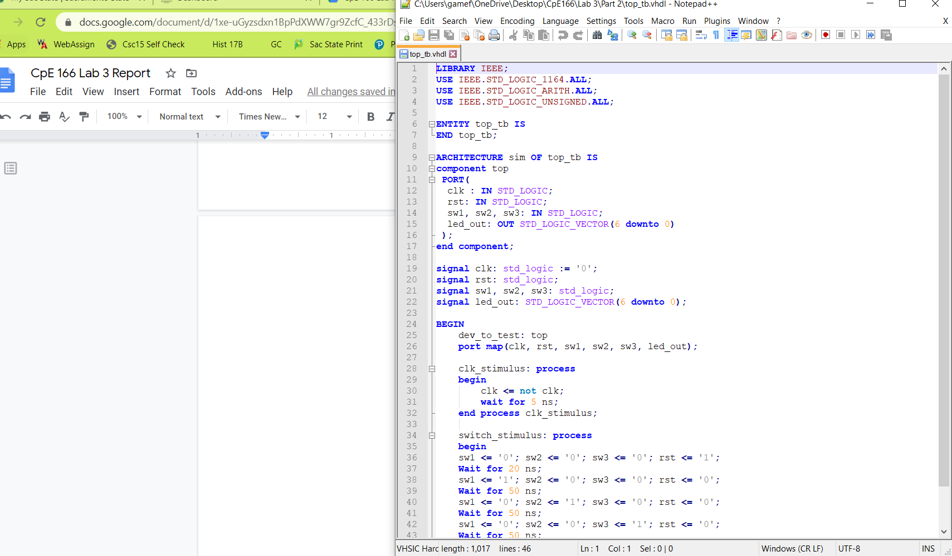

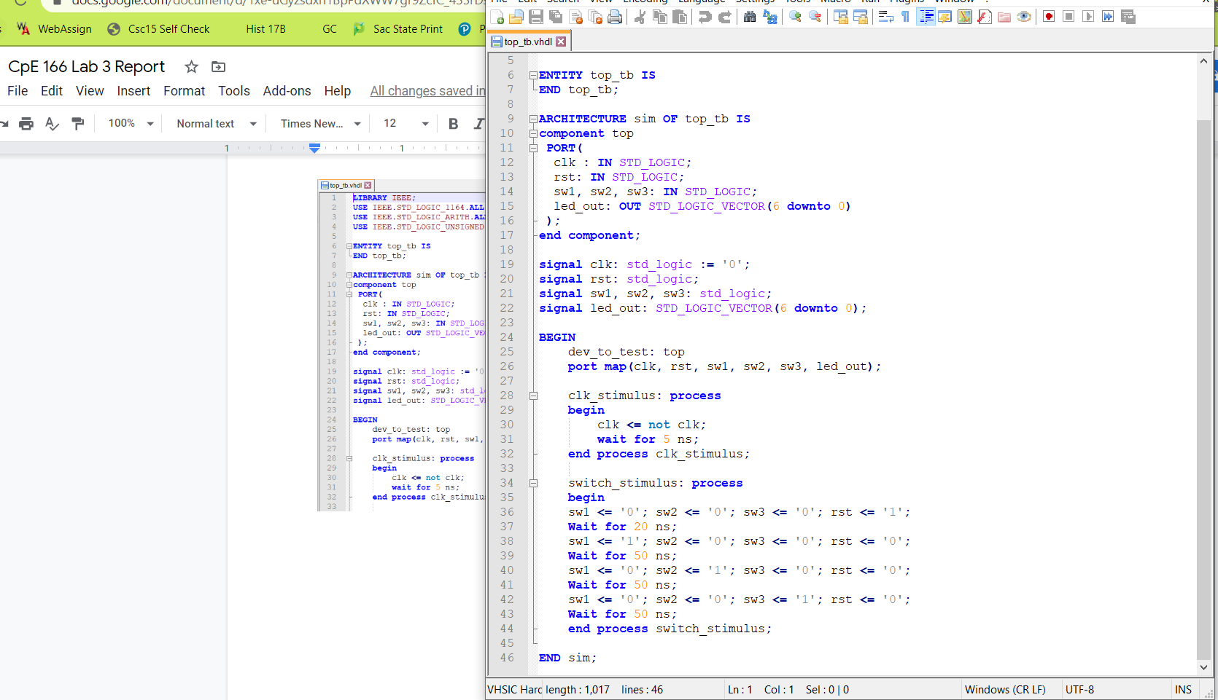

**Simulation Waveform:**

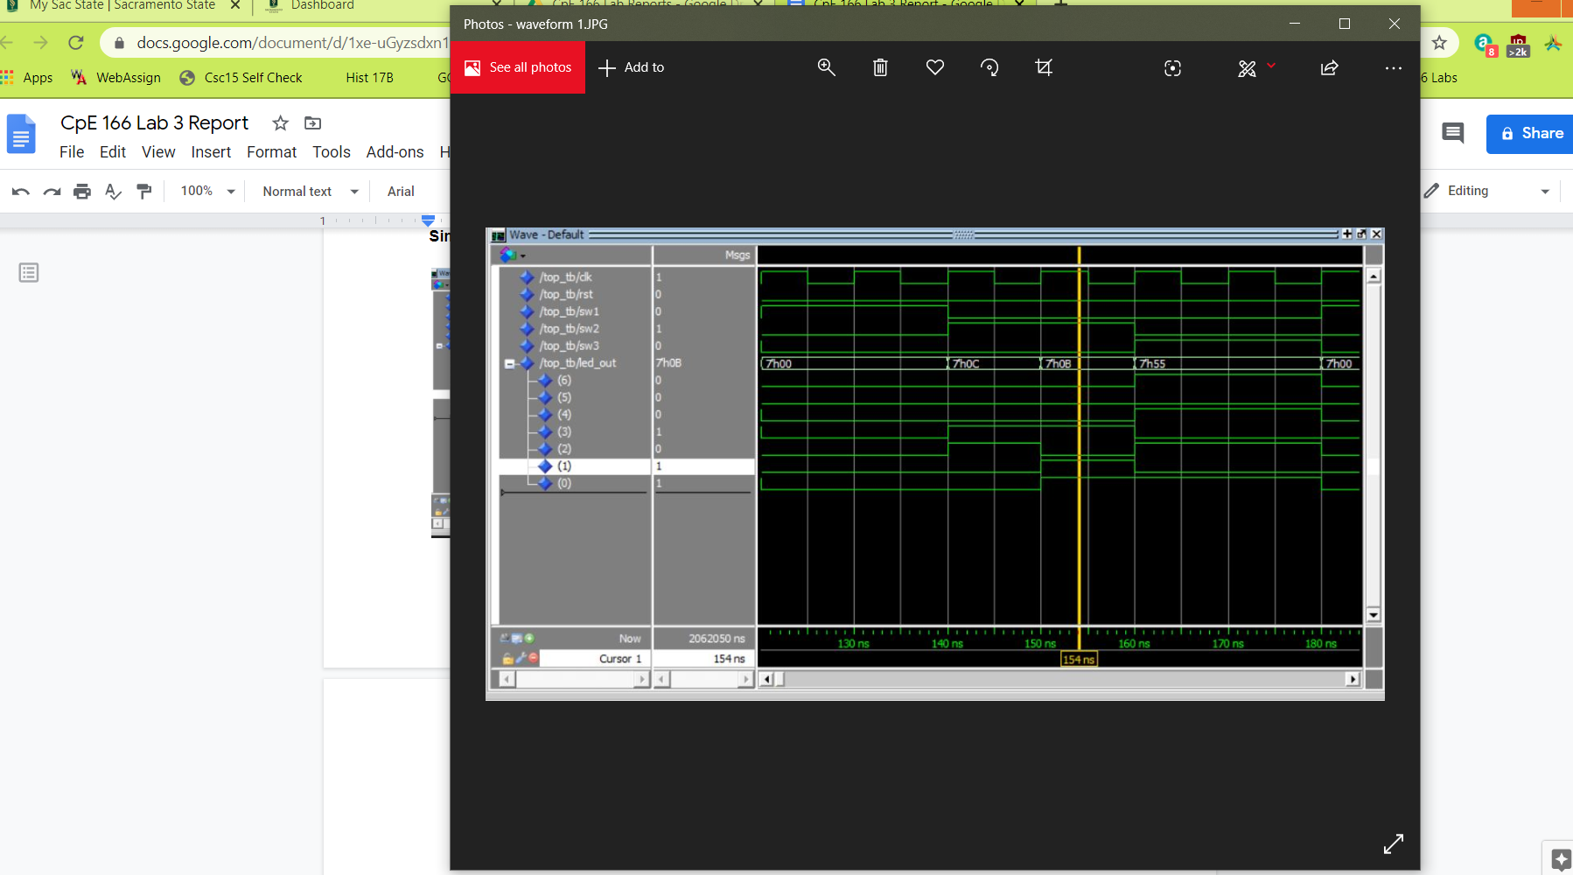

In the waveform above, we can see that when rst and SW1 is ‘1’ at the start, led_out displays ‘0000’. When SW2 is ‘1’ we see that led_out displays the LFSR message ‘0001011’. When SW3 is ‘1’ led_out displays the hamming code ‘1010101’.

**Result Discussion:**

The waveform shows that the LFSR and Hamming code works correctly. The hamming code is looking at the even parity to determine if there is an error in the 4 bit message. The LFSR and hamming code was explained and examples were given on the course webpage to help. The hard part was creating the FSM and the top file. The FSM was not producing the correct output and the top file was hard to wire all the files together correctly. Creating the testbench was also a challenge but this part gives good experience with hierarchy design.

**Part 3: Calculator Design with Multiplexed Seven Segment Displays**

**Design Purpose:**

This lab introduces an arithmetic logic unit. We also have to change the initial sequence period of 15 clock cycles to a sequence at 1 Hz. This design has 4 switches: switch 1(SW1), switch 2(SW2), switch b3, and switch b4. SW1 will reset the design. When SW2 is high, it enables the LFSR to run so it displays the 4 bit data. When SW2 is low, the LFSR is disabled. b3 and b4 determine the calculator function. This calculator would use a 4-bit pseudo-randomly generated number from the LFSR, split it into two 2-bit numbers, and perform a calculation determined by the user’s input. The calculator performed four functions: add, subtract, compare, and NAND.

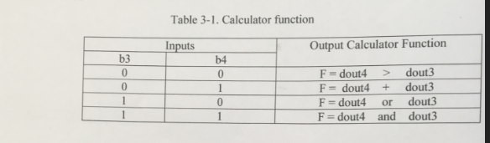

**Design Experiments:**

This part of the lab we have 7 files:

clock_div - this file will change the original clk cycle to a 1Hz clock cycle

input - this file will determine if the output will be loaded to the fsm or resetted

lfsr - this file will do the arithmetic math of the 4 D-flip-flops for the LFSR

calculator - this will determine the calculator function to perform depending on b3 and b4

fsm - fsm will have 3 states determining the output: clear, display LFSR, or calc. function

top - puts clock_div, input, lfsr, calculator, and fsm file to create the final circuit.

top_tb - testbench for the top file to demonstrate waveform

**Design Source Code:**

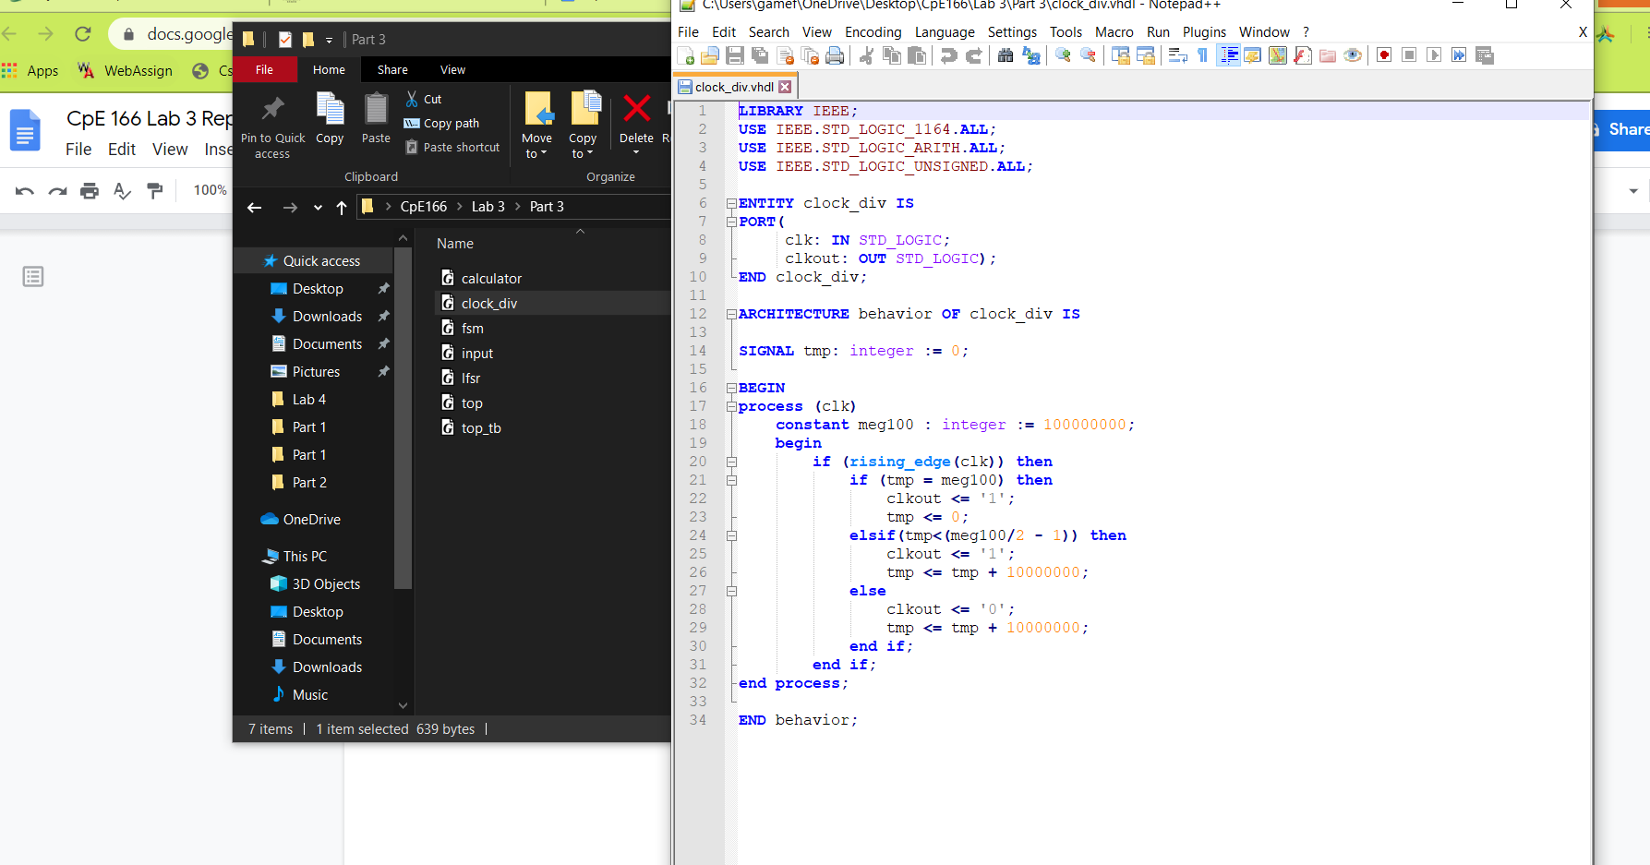

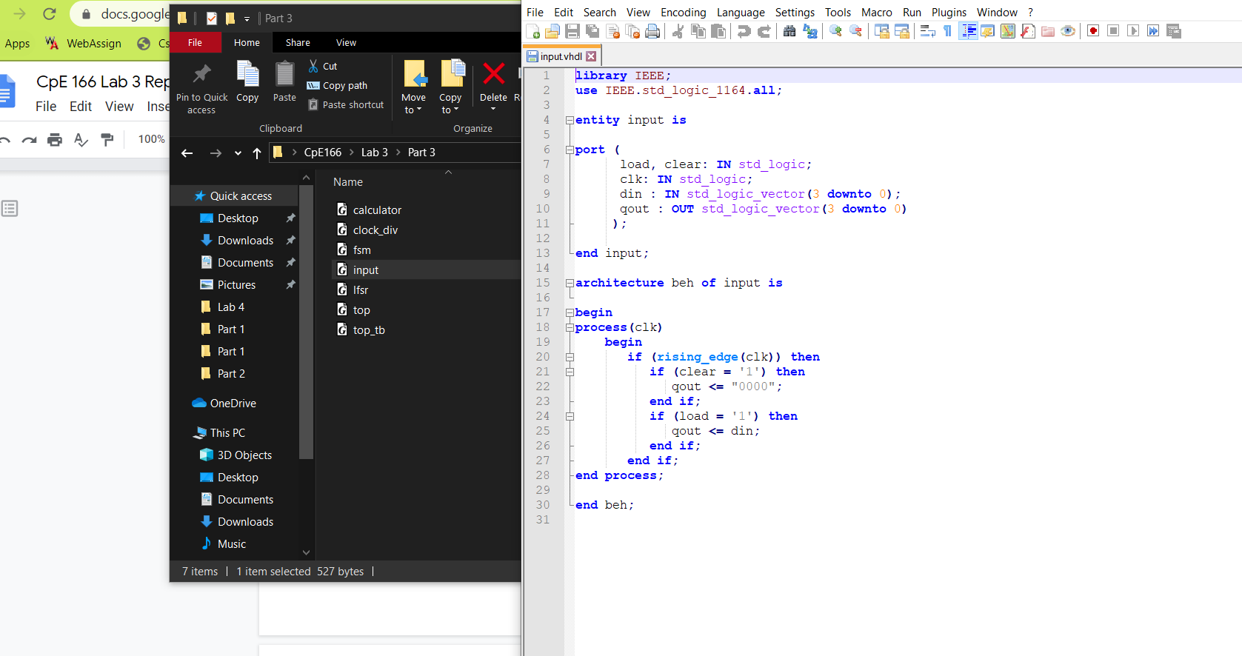

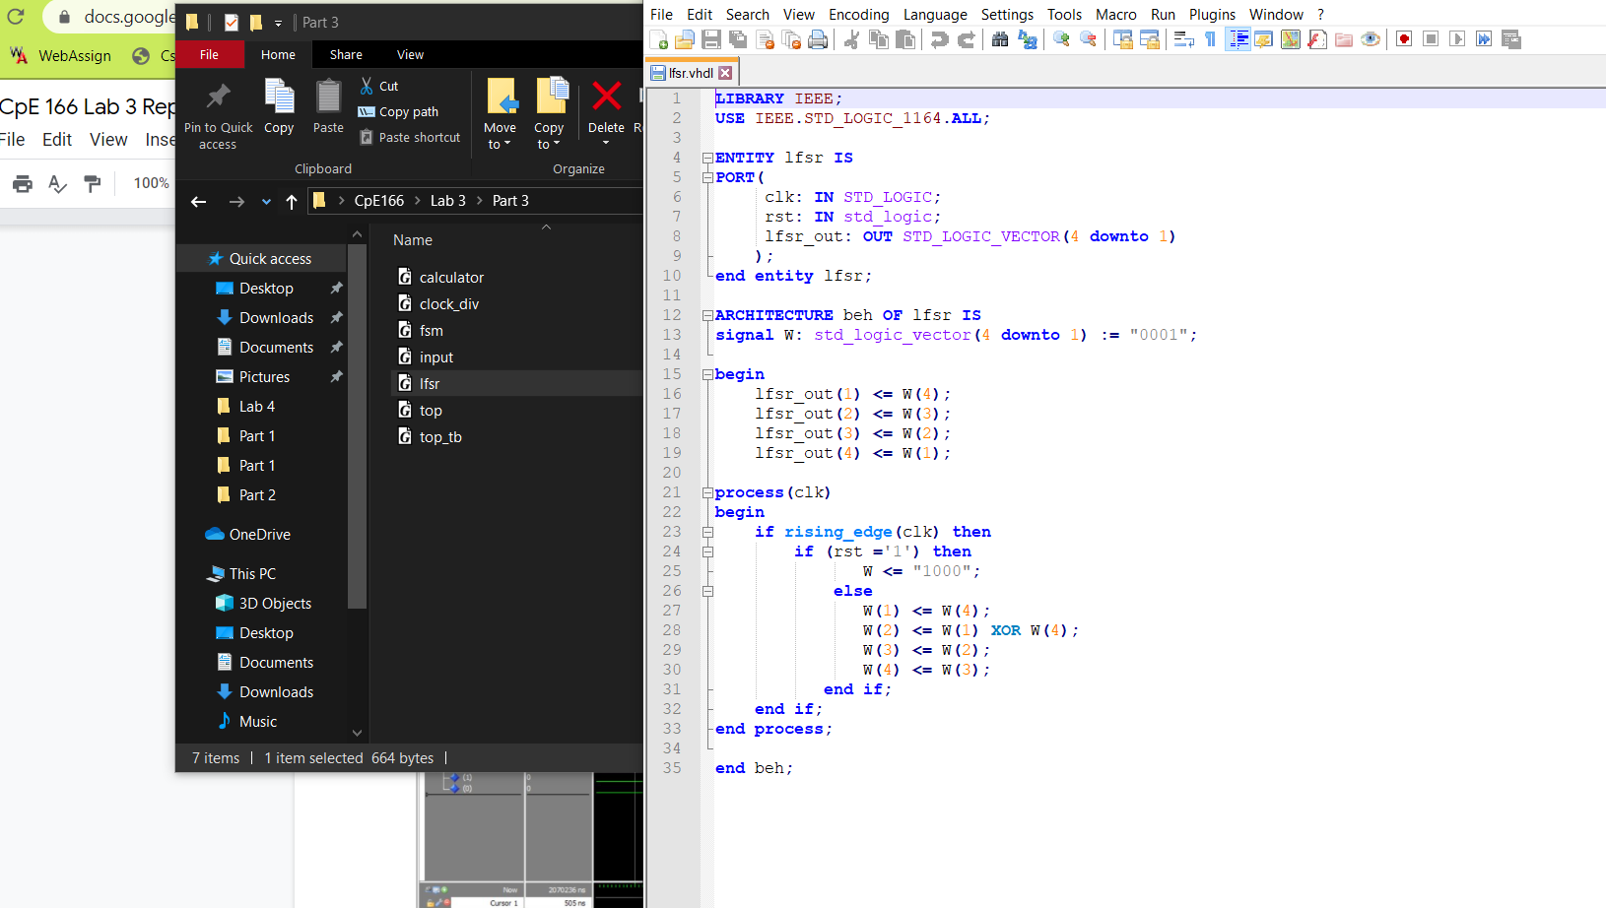

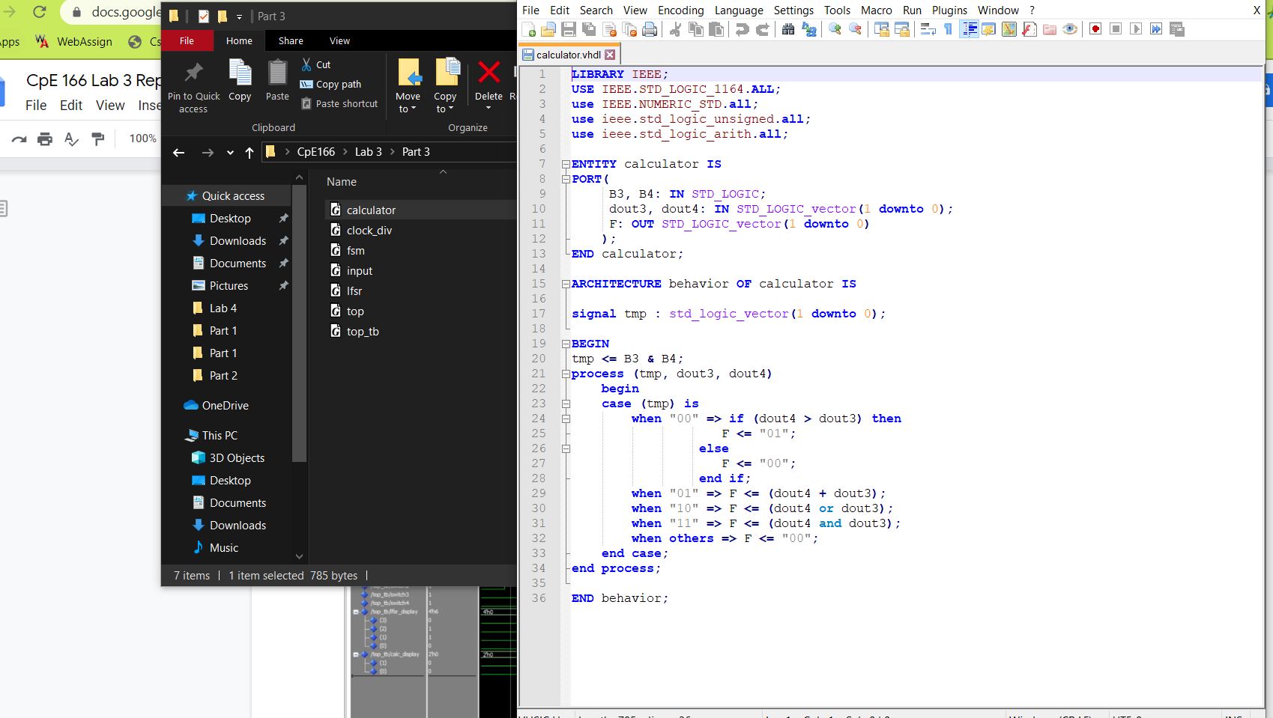

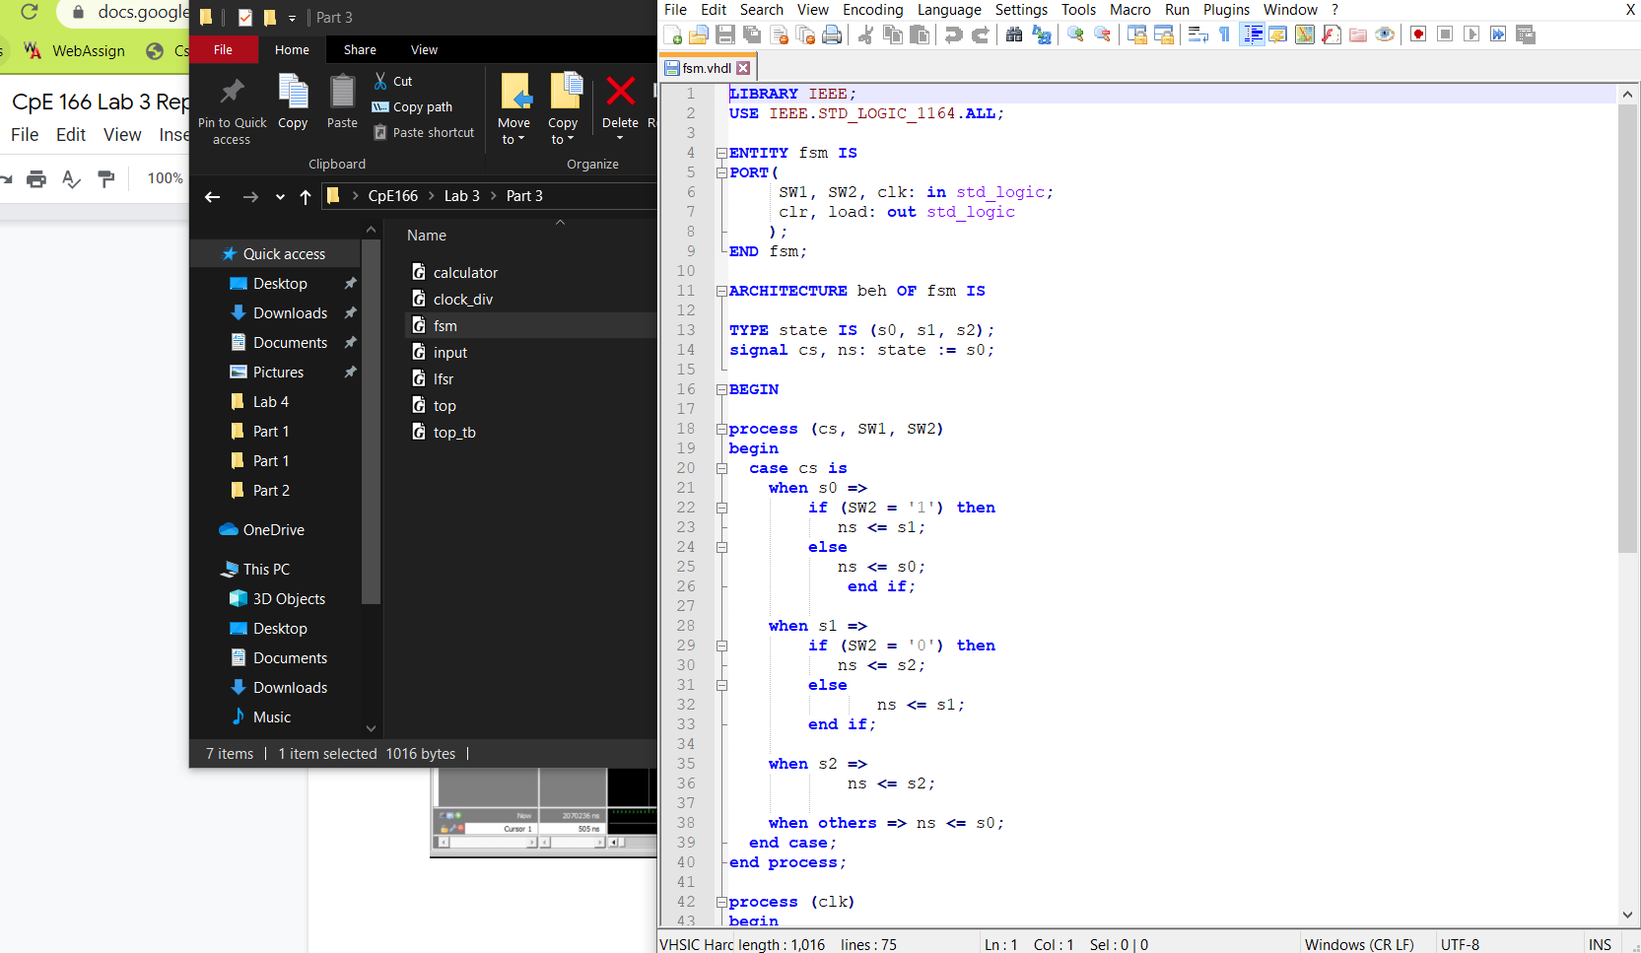

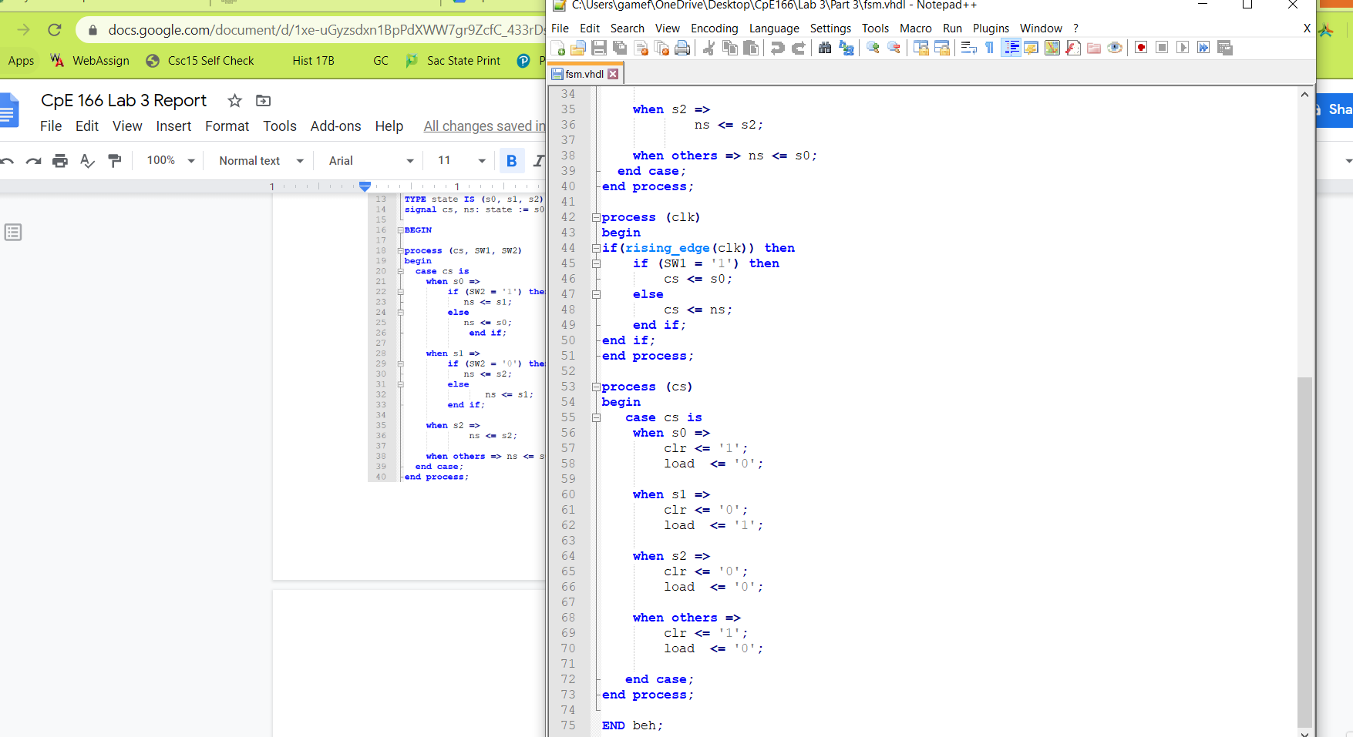

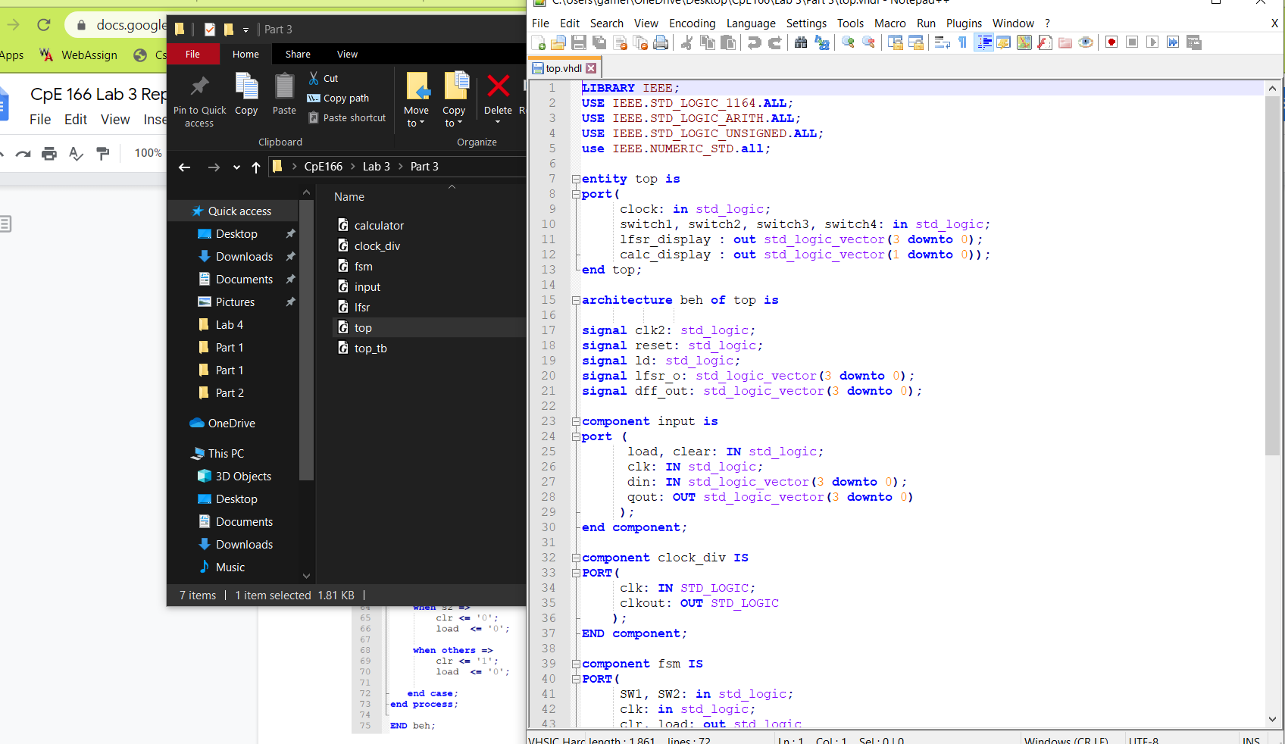

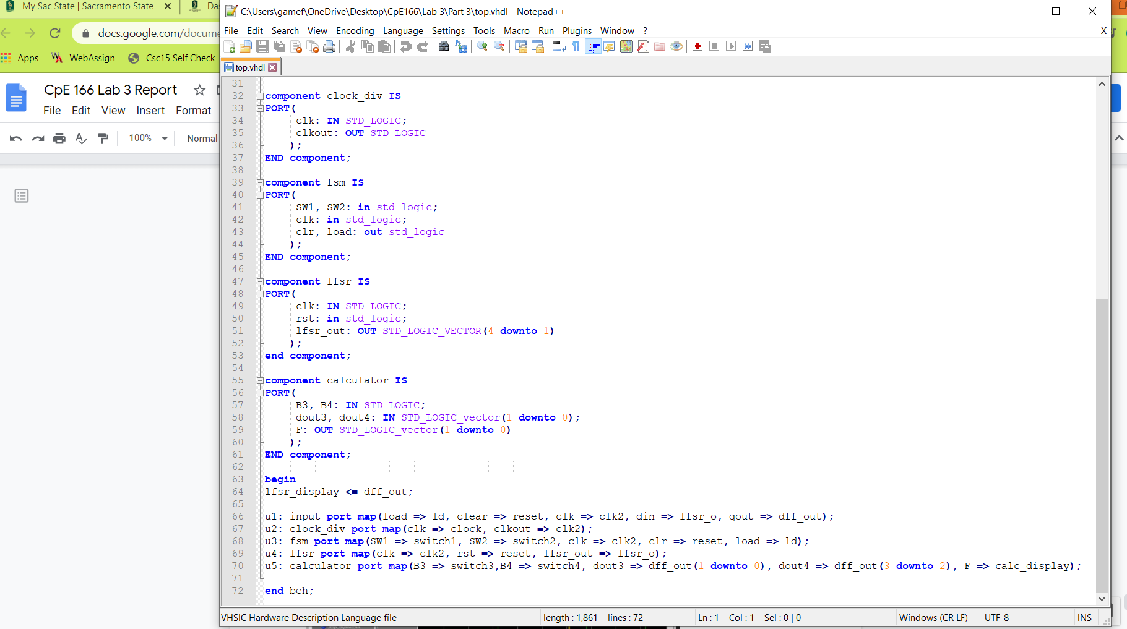

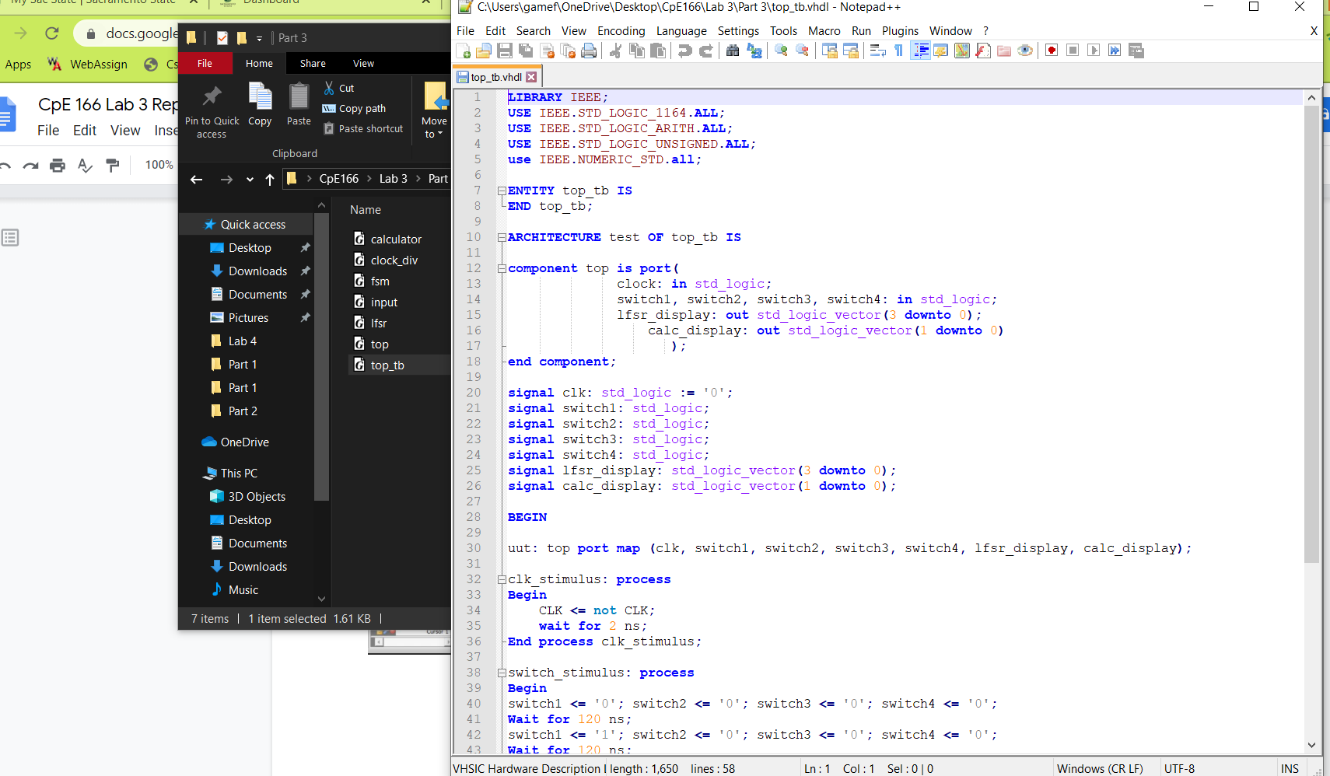

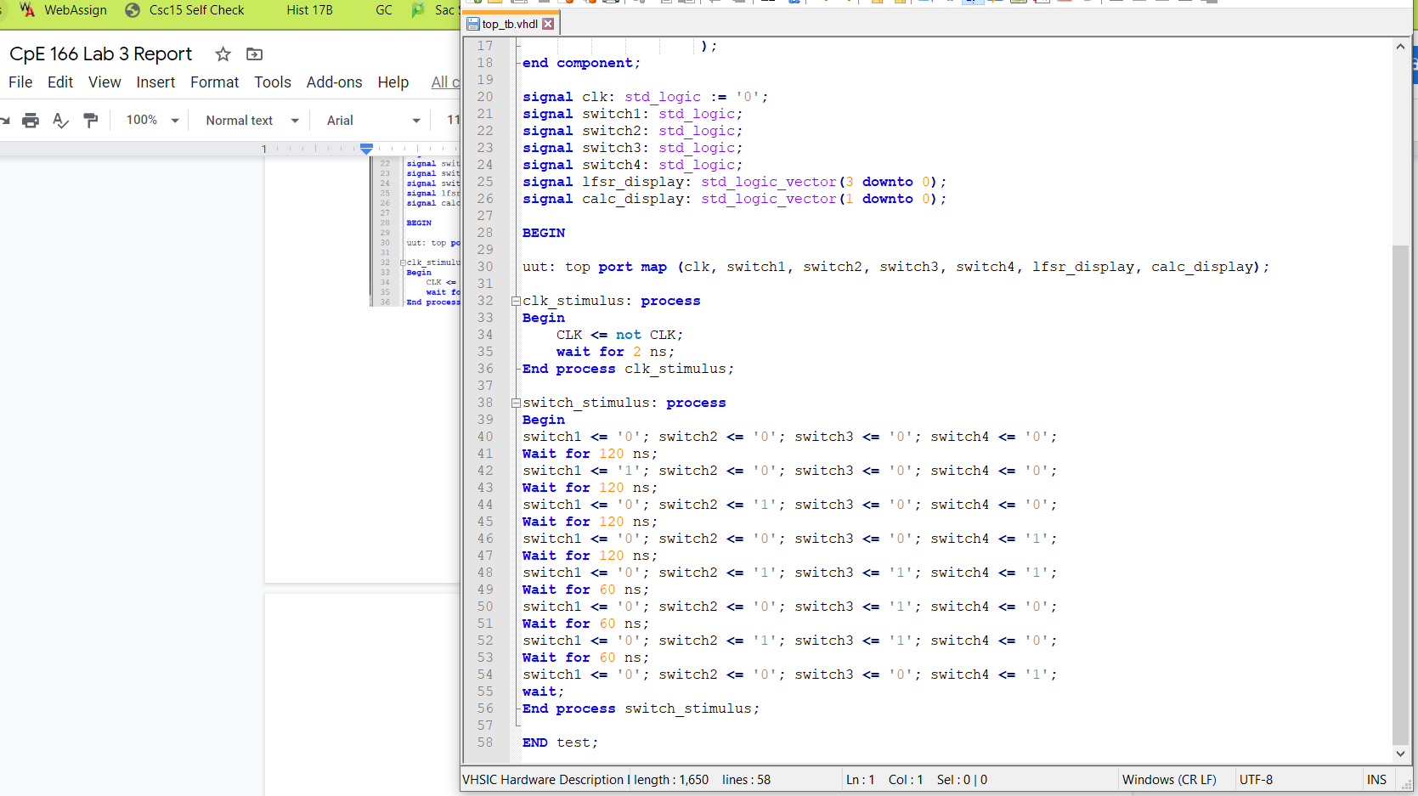

**Simulation Waveform:**

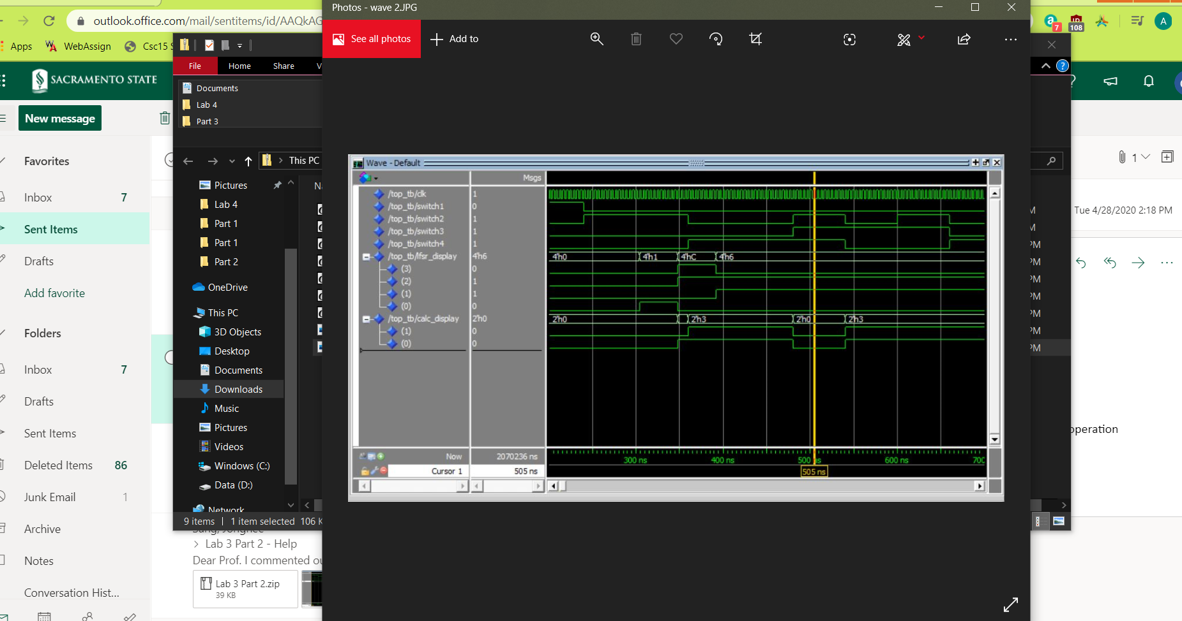

The waveform above shows the clk, the 4 inputs, and the 2 outputs. We see that when SW2 is on, the LFSR is activated. When SW3 is on we see that the calc_display displays the correct function by looking at switch 3 and switch 4 which is an AND operation because both switches are ‘1’. To see if it is correct, we split the 4-bit LFSR ‘0110’ into 2 bits: ‘01’ and ‘10’. The output is ‘00’ so it’s correct. If we look elsewhere we can see that the other operations are performed as well.

**Result Discussion:**

The calculator will perform the 4 tasks it is supposed to do depending on the finite state machine. The FSM has 3 states and depending on the input will determine whether or not to clear, display LFSR, or calculator function. This lab used hierarchy design which is always a challenge to put everything together. The final results were simulated correctly. The calculator was able to add, subtract, compare, and NAND two numbers.

## **Part 4: RAM Design and Logic Analyzer**

**Design Purpose:**

The objective of this part will be to design a RAM. In our RAM design, we will need to write binary data 4’b1010 into 16 address locations of the RAM. After completing writing, we need to read data out of the RAM as well. We will run simulations on the design to show the result.

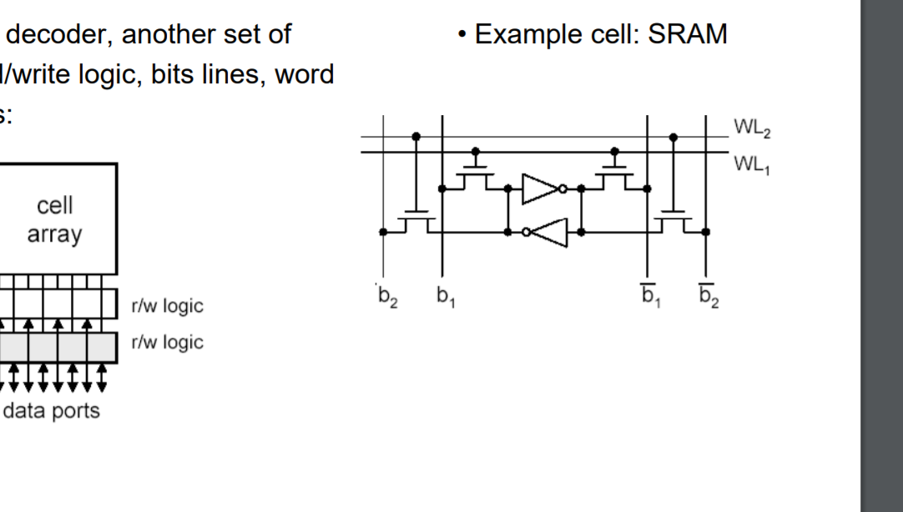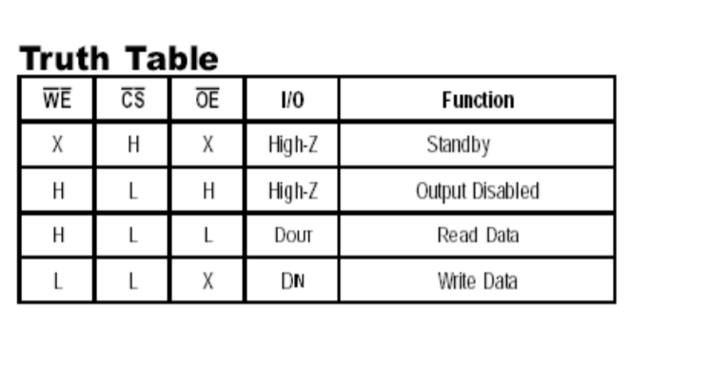

**Design Experiments:**

For this part of the lab, we only need 4 files:

ram - this will determine the function from the truth table with: we, cs, oe

mem_fsm - there will be 5 states to determine the output depending on inputs

mem_top - puts ram and mem_fsm file together to create final circuit

top_tb - testbench for mem_top to display results of ram

**Design Source Code:**

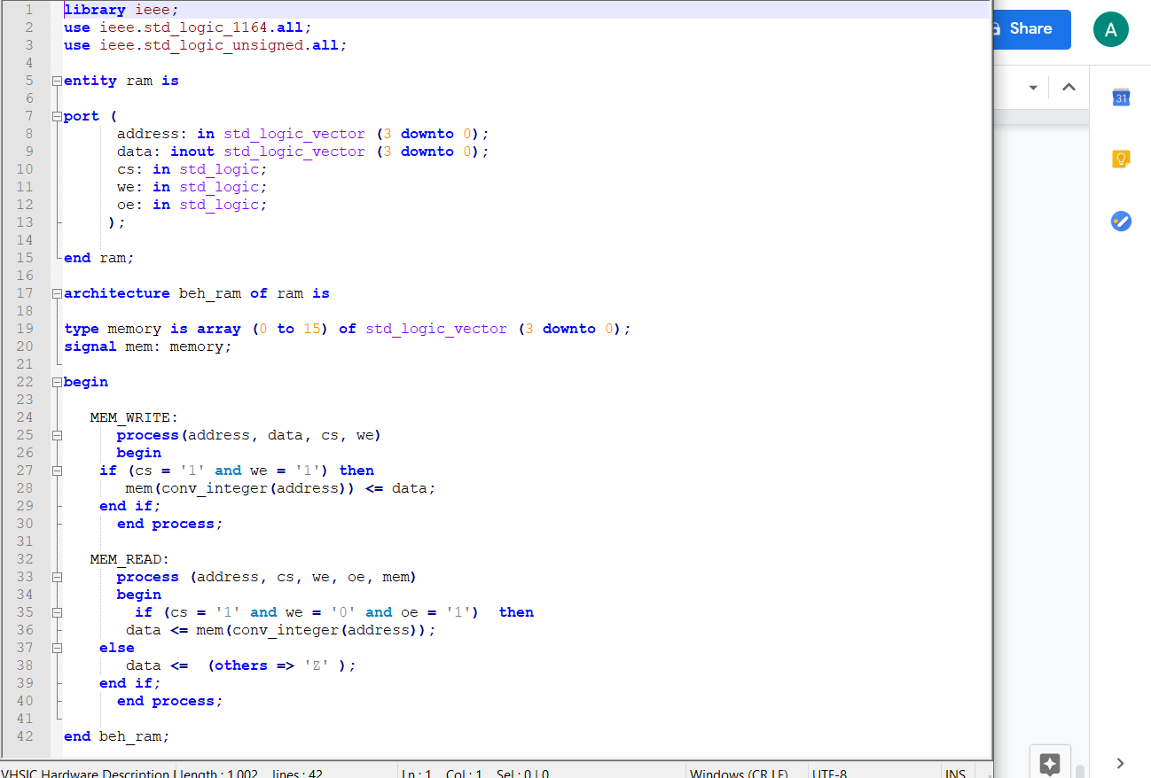

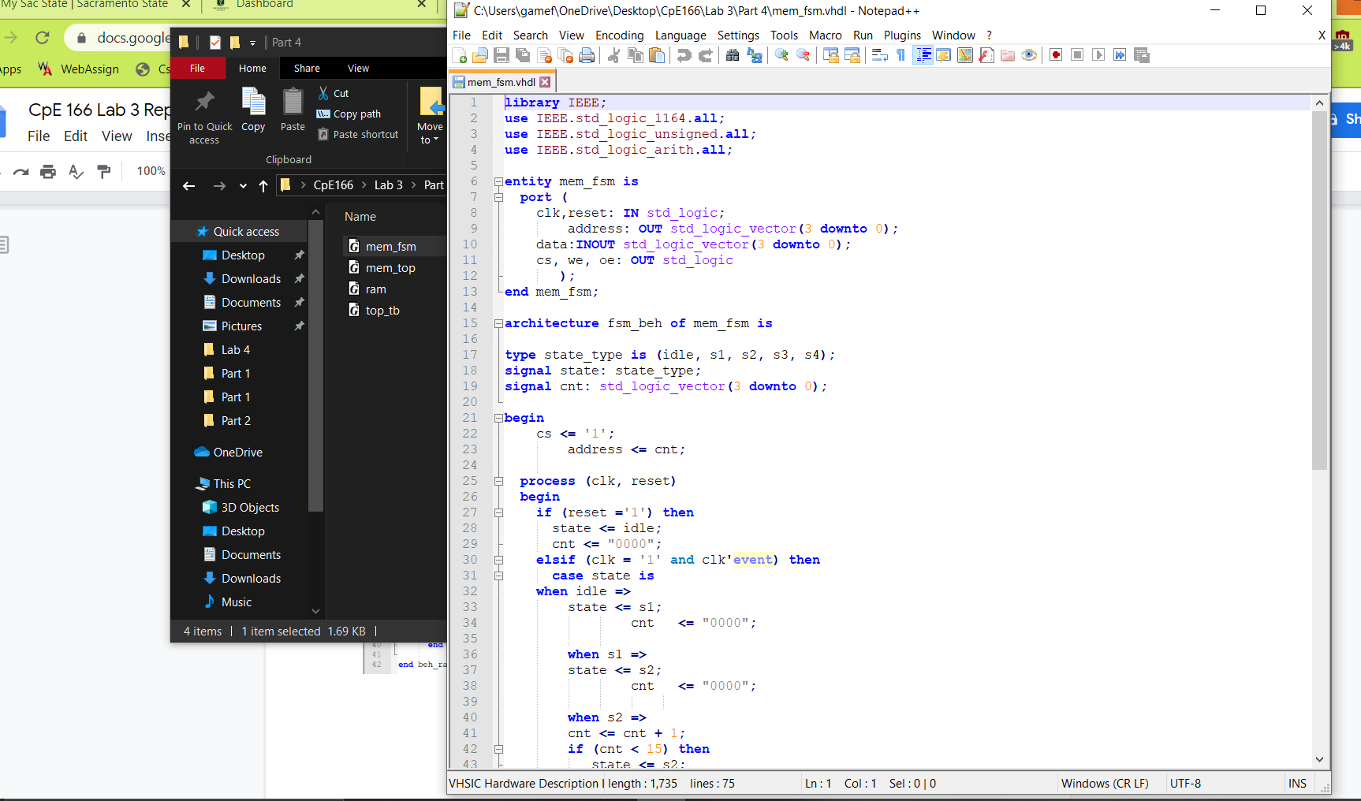

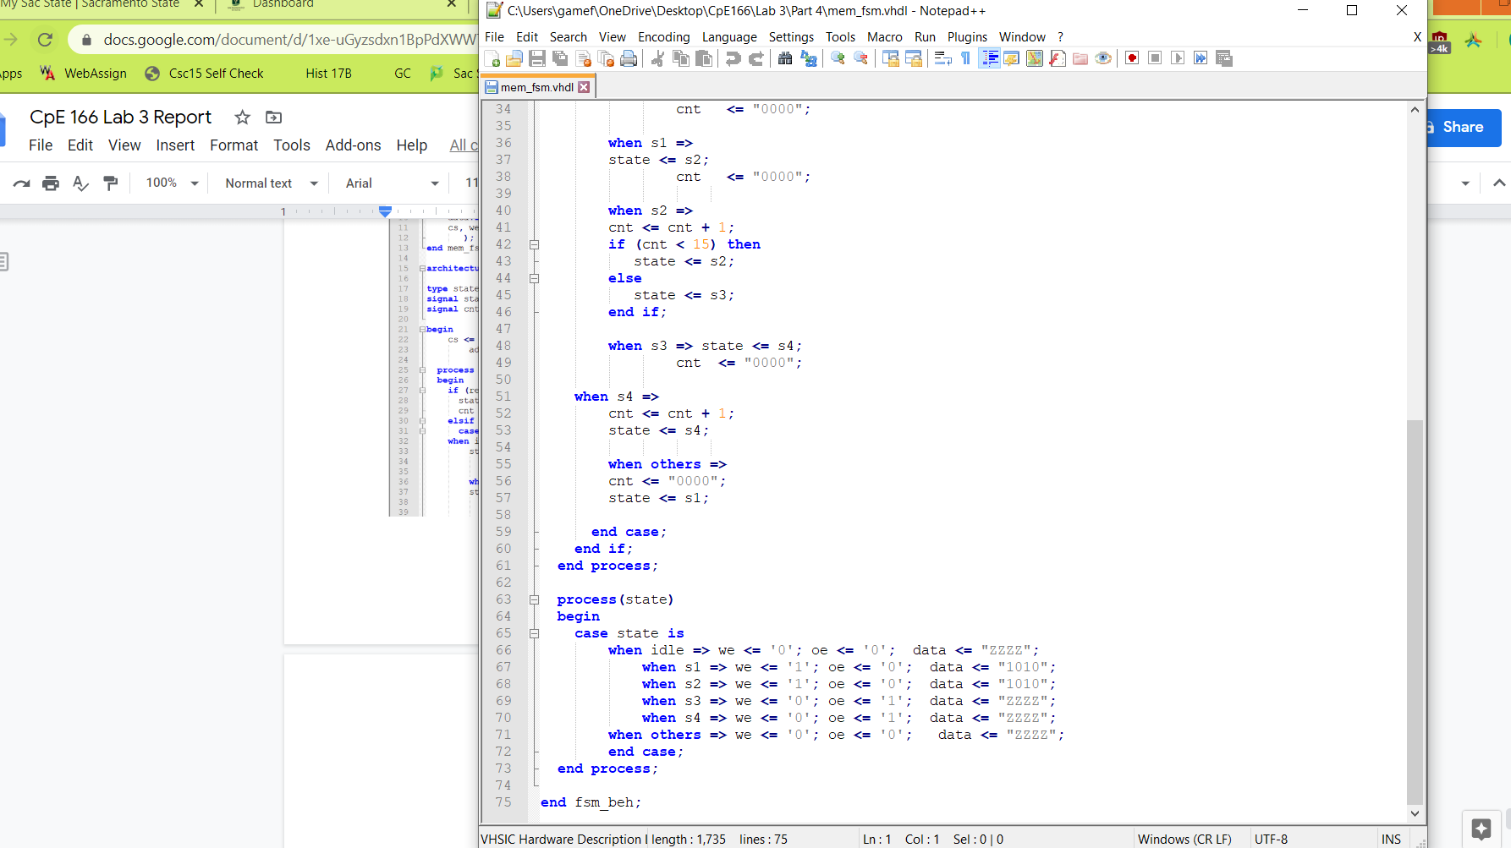

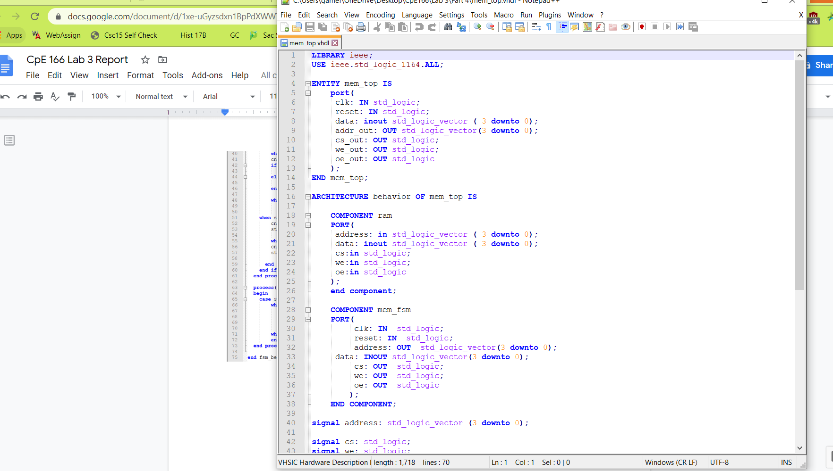

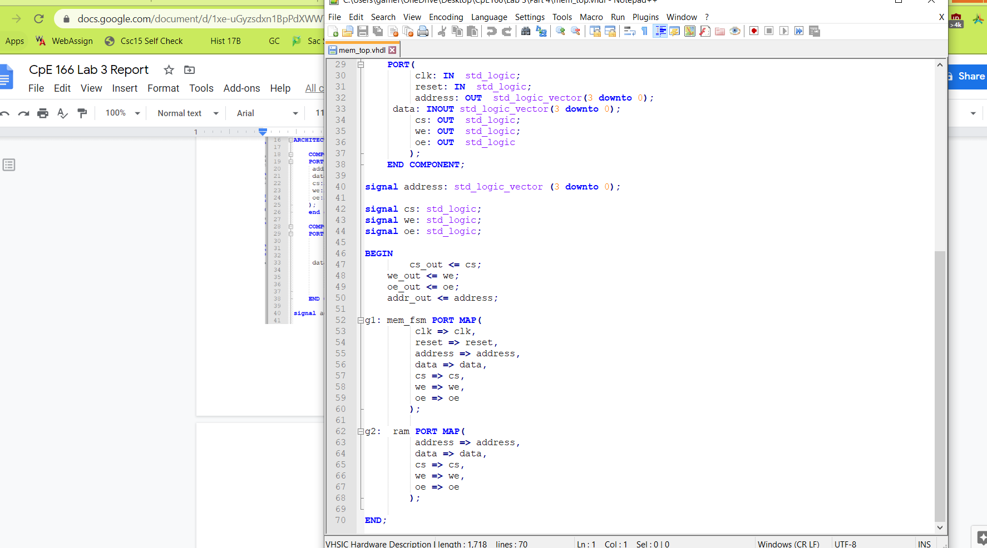

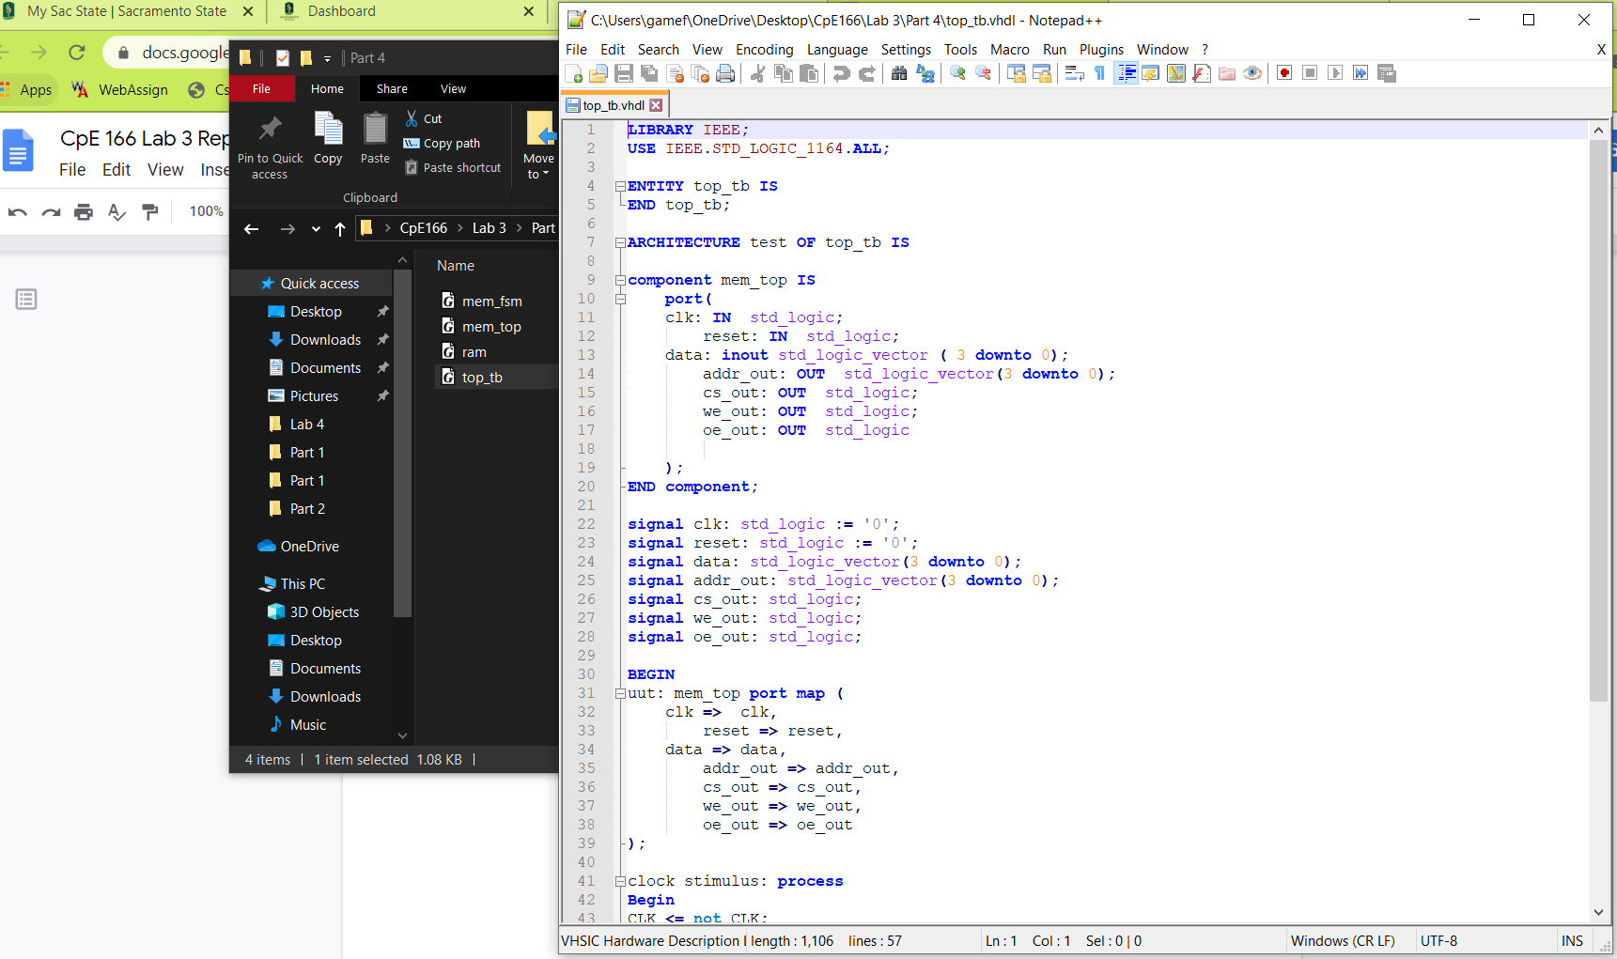

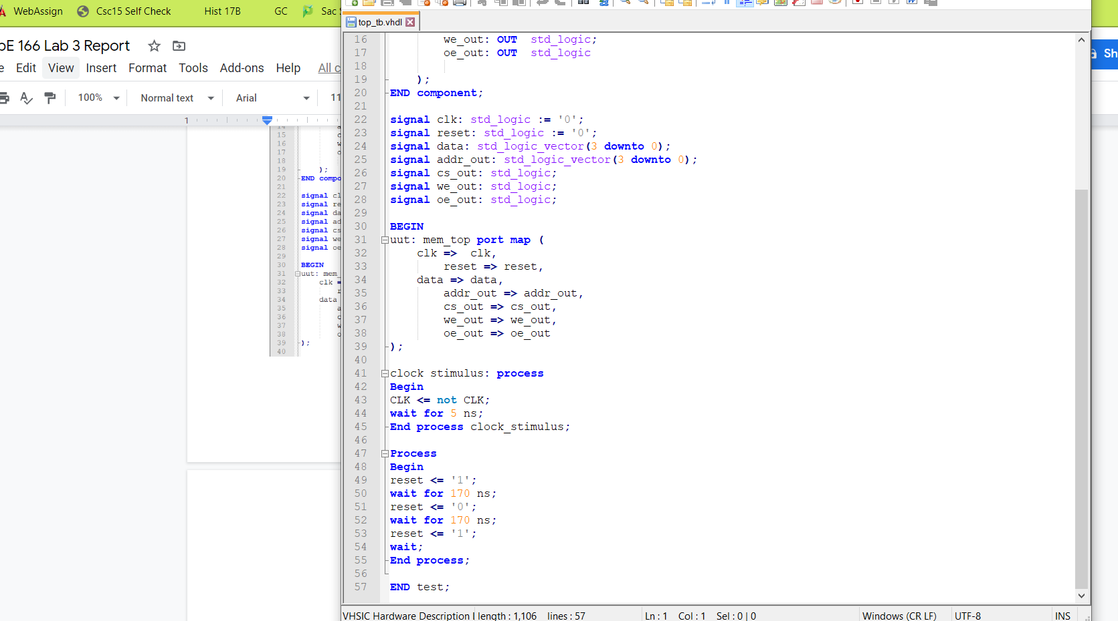

**Simulation Waveform:**

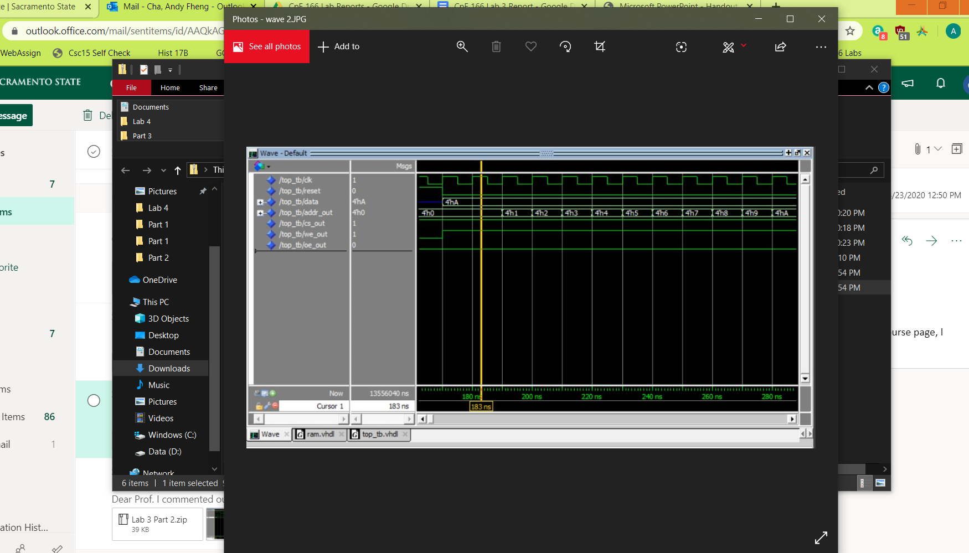

**Result Discussion:**

The 4 bit binary data ‘1010’ was stored successfully into the 16 address lines of SRAM. This part of the lab was easy because the mem_top, ram, and mem_fsm was given by the professor on the course webpage. The only thing we had to write was the testbench for the top file. This part was a good introduction to how SRAM functions and works.

**Conclusion:**

In this lab, I was able to learn how to implement various circuits with finite state machines using VHDL. We were also introduced to how to create a clock division so that we can see the results. I was able to gain experience utilizing the concepts of hierarchical design to structure my code in such a way that it is easy to understand the circuit piece by piece. We learned how to build a Linear Feedback Shift Register (LFSR) and how to generate a hamming code. The final part of this lab introduced the features of SRAM and how to write data into memory location. Overall, I was able to complete all of the sections in this lab.

## 